**Experiment - 1**

**Date of Performance: 26/03/2022 Date of Submission: 09/04/2022**

**DIV: A** **Batch: A4**

**Team Members:**

**Name: SAP ID:**Dhruvi Jodhawat 60004190032

Harvy Gandhi 60004190043

Junaid Girkar 60004190057

**Aim:** To identify a suitable life cycle model for your case study and justify your choice

**ABSTRACT:**

The main aim of this case study is to analyse tourist’s behaviour based on the locations and places they have visited so far, to identify tourist interests, popular locations and to plan future tourism demands. It supports strategic decision-making in tourism destination management.

Due to the covid crisis, the tourism industry of our country has been facing a lot of repercussions. The [pandemic](https://en.wikipedia.org/wiki/COVID-19_pandemic) has a huge impact on the tourism industry due to the resulting travel restrictions as well as slump in demand among travellers.

The collapse in travel will bring long-term changes. The aim of this project is to help the government and states to revive the interests of people in travel.

**Features:**

1. Make use of geotagged images on social media for data extraction.
2. Structure the tourist demographic data for all the locations in the vicinity.
3. Predict tourism demands for various locations with the help of time variant data.
4. Develop a comprehensive review system with the help of image and text processing which can be passed on to relevant authorities.

**Overview-** Extremely large amounts of data can be collected from social media sites about people who have visited a particular place. While this data will not be in a presentable form, with help of certain data processing techniques, we can make use of this data and provide it to the government or the local authorities and inform them about various tourism interests in their areas. Hotel Chains and Restaurants can also use this data for knowing which periods have the maximum tourist footfall and plan accordingly. By comparing monthly tourism traffic data over the years, we can try and identify strategic decisions which led to the boom of tourism at a particular place and also some logistical shortcomings which if corrected will lead to more tourists at that place. This can also work as a ‘Places to Visit’ guide for tourists who know nothing about a particular place.

**Process Model: Spiral Model, RAD Model and Waterfall model**

**Our Choice: Spiral Model**

**JUSTIFICATION:**

**Why not the waterfall model?**

* In waterfall model, early stage planning is critical and we won’t have all of the requirements available at the beginning of the project
* Also, the waterfall model is more suitable for small-scale projects and since our project would require data on a global level, waterfall model is not preferred.
* The waterfall model is inflexible to changes and our model will have to be continuously updated after frequent reviews, the waterfall model won’t fit our needs.

**Why not the RAD model?**

* In RAD, testing is done after completion of the project whereas our model will need to be frequently tested as and when updates are made.
* RAD model is more suitable for small-mid scale projects, less time consuming projects whereas our project is on a large scale.

**Why the Spiral model:**

1. This model is easily acceptable to the ever-changing needs of the project. The tourist analysis behaviour requires constant extraction of data, cleaning of the data and analysing it to propose it to the local authorities. However, the data keeps varying over time hence requiring a change in the analysis of the same.
2. More resources are required for the spiral model. Huge amounts of data is extracted by social media accounts as well as from the local authorities, hence providing adequate resources.
3. The local authorities after testing the proposed analysis may implement the solution and find it to be not entirely accurate. Hence improvements are required to be done on a regular basis. Hence the implementation may be changed repetitively due to imperfect requirements.
4. Once the analysis is done for a smaller quantity of data, the testing of the result can be done accurately. If during testing it is found that the solutions do not meet the expectations, changes can be made since it is a small iteration.

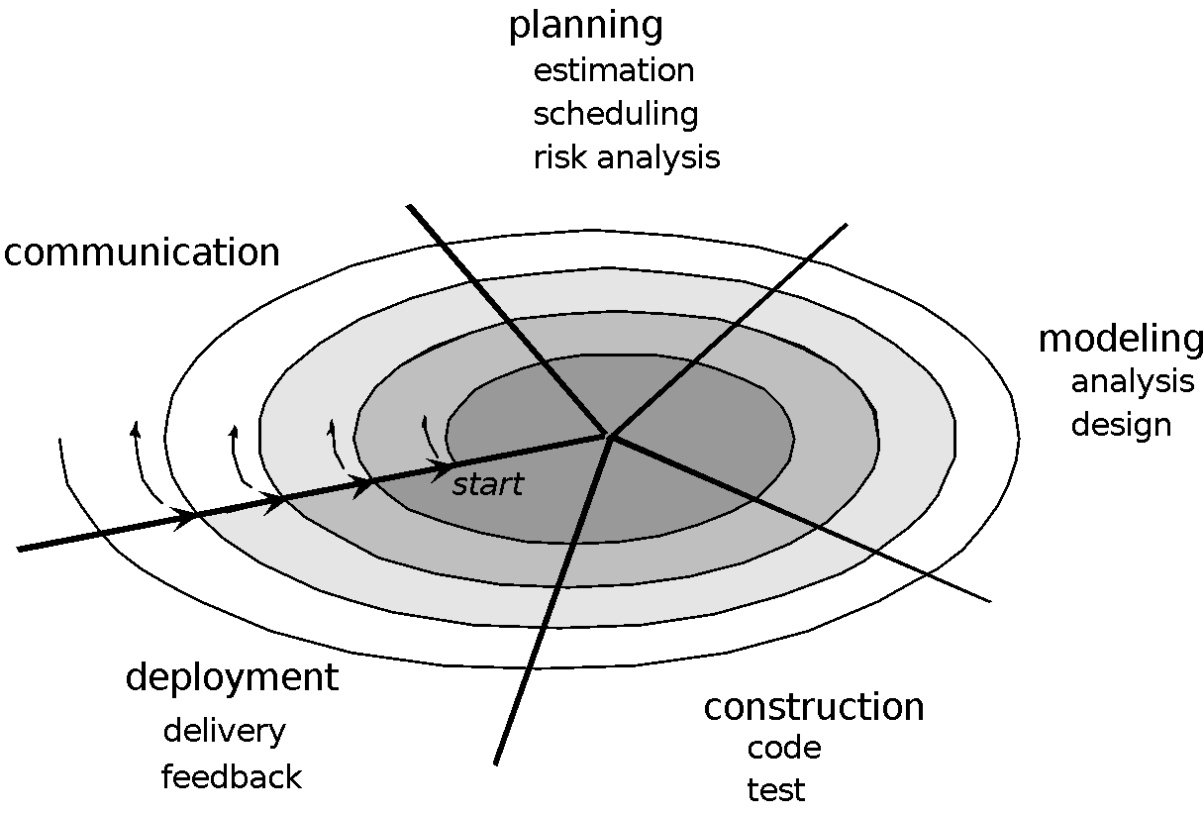

* 1. **Requirement gathering and analysis**: Communication is carried out with the local authorities to know the issues they have been facing and the ways they are undertaking to boost the tourism industry. Depending on the issues and the requirements they propose, we analyse them.
  2. **Planning and Modelling:** In these phases we design the flow of the process by various diagrams. The ways of data extraction and data analysis are decided.
  3. **Construction:** The data is cleaned, stored in the appropriate manner, various methods of analysis are applied on the data.
  4. **Testing:** The results found in the implementation phase are tested.
  5. **Feedback:**  In this phase review is to be performed to check the behaviour of the proposed solutions to the local authorities. Depending on the accuracy of the solutions, the process starts again from the new requirements gathering if any and design, implementation, review etc.
  6. **Deployment:** After completing all phases, the final solutions are proposed as a research paper.
  7. **Maintenance:**  If there are any changes occurring over time, they can be reflected in the research paper.

**CONCLUSION:**

We learnt about the different types of process models and justified the most suitable life cycle model for project execution in our case study.